SUMMERVILLE CREDIT UNION · CONSOLIDATED MEMBER GUIDE
Card Controls

Module: nFinia Digital Banking > Cards > Card Details > Card Controls
01 PRODUCT SUMMARY

Card Controls is the central panel for managing how, where, and how much your card can be used. It brings together four sub-features — Spending Limits, Usage Control, Card Alerts, and Location Controls — in a single tabbed interface accessed from within any card's Card Details page.
Each sub-feature works independently and can be configured without affecting the others. Together they give you comprehensive control over your card security and spending behavior, all without contacting the credit union. Card Controls are available for both debit and credit cards.

At a Glance
Attribute | Detail
Module | nFinia Digital Banking > Cards > Card Details > Card Controls
Spending Limits | Set per-transaction and per-month spending caps
Usage Control | Enable or disable specific transaction types and merchant categories
Card Alerts | Configure notification alerts for card activity
Location Controls | Restrict or permit transactions by geographic location
Related Documents | Spending-Limits, Usage-Control, Location-Controls (separate guides)

02 KEY USE CASES

Use Case | Who Uses It | What They Do | Business Value
Set spending limits | Member managing a budget or secondary card | Opens Card Controls > Spending Limits, sets per-transaction or monthly cap | Large or unexpected charges are automatically declined
Block specific merchant types | Member restricting card to certain uses | Opens Card Controls > Usage Control, disables unwanted merchant categories | Card declined at disabled merchant types
Enable card for travel | Member traveling internationally | Opens Card Controls > Location Controls, enables international transactions | Card approved in selected travel destinations
Review all controls | Member wanting to audit card settings | Opens Card Controls and reviews each tab | Full visibility of all active controls on the card

03 STEP-BY-STEP GUIDE

Navigation: Log in to Summerville Credit Union online banking. Click Cards, select your card, then click Card Controls.
Step 1 — Arrive at the Dashboard
After logging in, you land on the Dashboard showing your account balances, recent payments, and quick-action shortcuts. Click Cards in the top navigation bar, then select the card you want to manage.
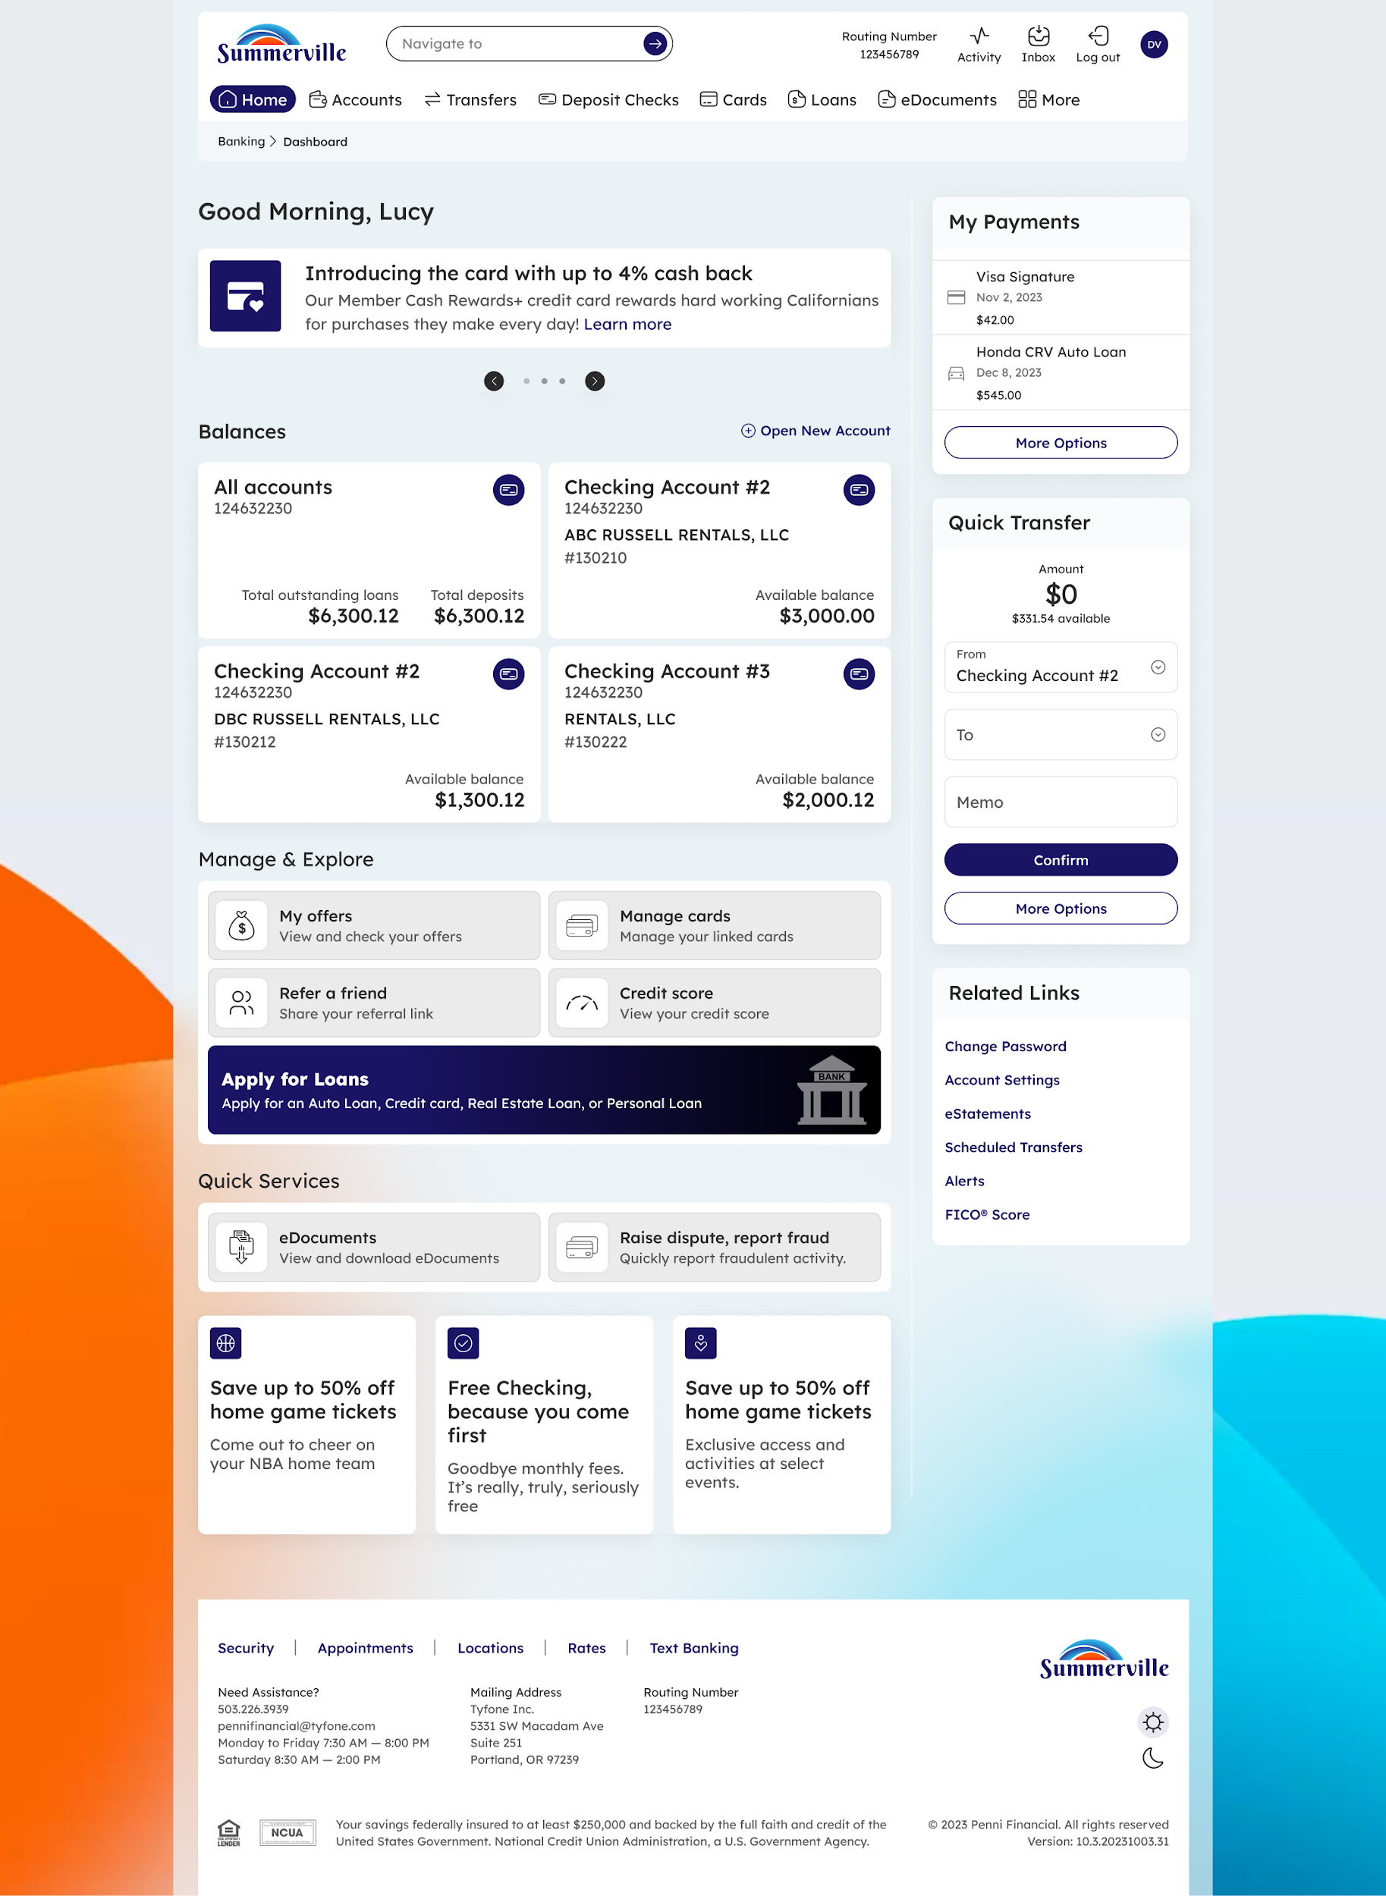
Step 1: Dashboard — starting point for navigation
Step 2 — Open Card Controls and Choose a Sub-Feature
From the Card Details page, click Card Controls in the quick action row beneath the card balance summary. The Card Controls panel opens with four tabs: Spending Limits, Usage Control, Card Alerts, and Location Controls. Click any tab to configure that sub-feature. Each setting takes effect immediately when saved — no additional confirmation step is required.
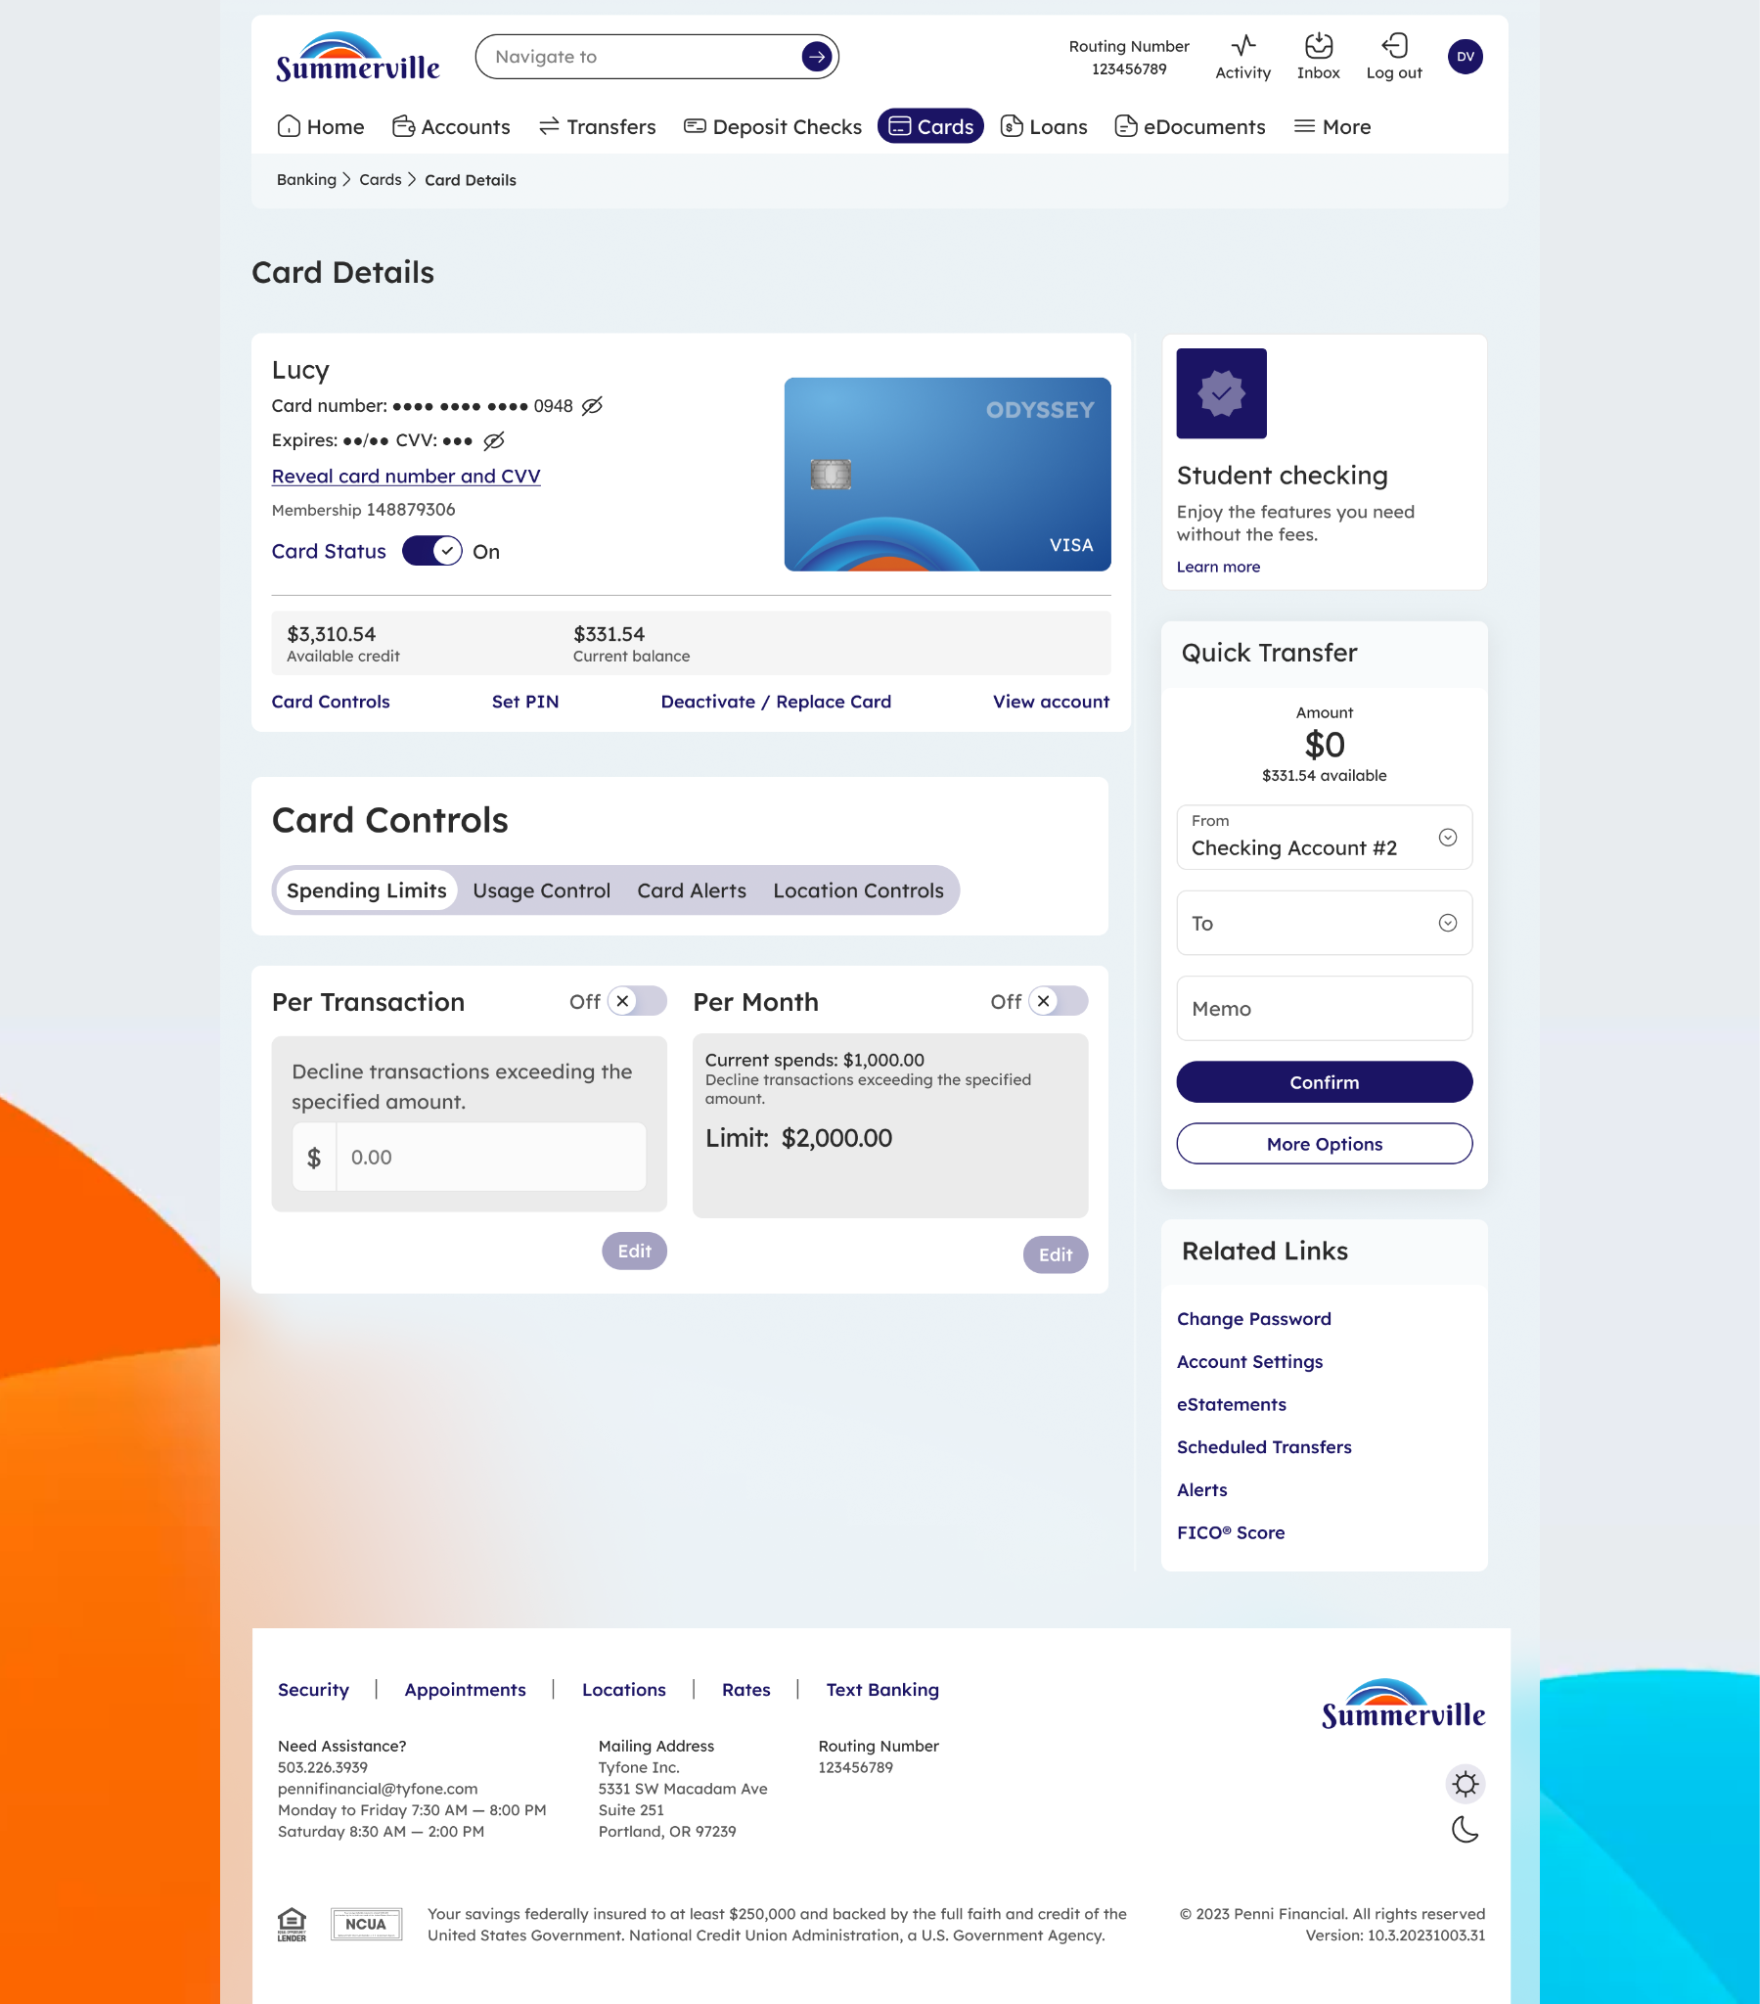
Step 2: Card Controls panel — select any tab to configure that control area
Note: Each Card Controls sub-feature has its own detailed guide: see Spending-Limits, Usage-Control, Location-Controls, and Card-Alerts for step-by-step instructions on each tab.

